**Crop Prediction Using Machine Learning**

**SmartBridge Applied Data Science Internship**

**Project Report**

***Submitted by:***

**TEAM 48**

| **1.** | **Stuti Mahajan** | **20BHI10018** | **Vellore Institute of Technology, Bhopal** |
| --- | --- | --- | --- |
| **2.** | **Mansi Sahu** | **20BAI10158** | **Vellore Institute of Technology, Bhopal** |
| **3.** | **Ujjwal Tajne** | **20BAI10381** | **Vellore Institute of Technology, Bhopal** |
| **4.** | **Abhishek Kumar** | **20BAI10384** | **Vellore Institute of Technology, Bhopal** |
|  |  |  |  |



***Submitted to:***

***SmartInternz in partial fulfillment of the requirements for completion of Externship Program - Applied Data Science with SmartBridge***

 

**Table Of Contents**

| **Sl No.** | **Topic** | **Page No.** |
| --- | --- | --- |
| **1.** | Introduction | 3 |
| **1.1** | Overview | 3 |
| **1.2** | Purpose | 3 |
| **2.** | Literature Survey | 3 |
| **2.1** | Existing Problem | 3 |
| **2.2** | Proposed Solution | 4 |
| **3.** | Theoretical Analysis | 5 |
| **3.1** | Block Diagram | 5 |
| **3.2** | Hardware/Software designing | 5 |
| **4.** | Experimental Investigation | 6 |
| **5.** | Flowchart | 6 |
| **6.** | Result | 7 |
| **7.** | Advantages and Disadvantages | 8 |
| **8.** | Applications | 10 |
| **9.** | Conclusion | 11 |
| **10.** | Future Scope | 11 |
| **11.** | Bibliography | 12 |
|  | Appendix | 12 |

**1. INTRODUCTION**

**1.1 Overview**  
Crop prediction is a critical task for farmers and decision-makers in the agricultural sector. The ability to accurately forecast suitable crops for cultivation based on environmental and soil parameters can significantly impact agricultural productivity and profitability. This project aims to address this challenge by developing a crop prediction model that leverages machine learning techniques to provide farmers with informed recommendations.

The primary objective of this project is to assist farmers in selecting the most suitable crops for cultivation by analyzing predicted rainfall, soil contents, and weather parameters. By considering these factors, the model can predict the crops that are likely to thrive under specific conditions. Moreover, the model provides additional insights such as the required fertilizers (Nitrogen, Phosphorus, and Potassium) in kilograms per hectare and the necessary seed quantity in kilograms per acre for the recommended crop.

**1.2 Purpose**  
This project aims to empower farmers with accurate information for making crop selection decisions. By recommending crops suitable for prevailing environmental conditions, farmers can optimize their practices and improve yields. The system also provides market prices and approximate yields for the recommended crop, enabling farmers to consider profitability. The crop prediction model utilizes the Random Forest Classifier algorithm, known for its accuracy in handling complex datasets. By training the model on historical crop data and environmental parameters, it can learn patterns and correlations. The integration of the model into a user-friendly web application enhances its accessibility and usability, benefiting farmers in their decision-making process.

In conclusion, this project develops a crop prediction model that leverages machine learning and historical data to provide accurate recommendations based on environmental parameters. The model's integration into a web application empowers farmers to make informed decisions about crop selection, optimizing their practices and increasing profitability.

**2. LITERATURE SURVEY**

**2.1 Existing problem**  
Crop prediction and yield estimation are crucial for agricultural decision-making. Traditional approaches to crop prediction, relying on manual analysis of historical data, have limitations in terms of accuracy and efficiency. To overcome these challenges, this project proposes a machine learning-based approach. By leveraging historical data and advanced algorithms, the model aims to provide more accurate and efficient predictions for optimal crop selection. The integration of this model into a user-friendly web application enhances accessibility and usability, allowing farmers to input parameters and receive real-time crop recommendations. The system also provides information on fertilizers, seed quantities, market prices, and estimated yields. Future enhancements could involve incorporating real-time weather data, expanding the dataset to include more crops, and integrating additional features like pest and disease prediction.

In conclusion, the development of a machine learning-based crop prediction model offers a promising solution for improving traditional approaches. By leveraging historical data, advanced algorithms, and user-friendly interfaces, the model empowers decision-makers and farmers to optimize crop selection and enhance agricultural productivity. Continual refinement and expansion of the model hold significant potential for revolutionizing crop prediction and promoting sustainable agricultural practices.

**2.2 Proposed solution**  
This project proposes a machine learning-based approach for crop prediction by leveraging historical crop data and corresponding environmental parameters. The Random Forest Classifier algorithm is chosen as the foundation for the crop prediction model due to its suitability for classification tasks. By constructing multiple decision trees and combining their predictions, the Random Forest algorithm generates accurate predictions for crop selection based on input parameters.

The Random Forest Classifier algorithm effectively analyzes the relationships between environmental parameters such as rainfall, soil contents, temperature, humidity, and pH level. These factors significantly influence crop growth and yield. By considering these parameters, the model provides recommendations for the most suitable crop for cultivation.

The machine learning-based approach allows the model to handle complex patterns and interactions between environmental parameters and crop selection. By training the model on a comprehensive dataset of historical crop data, it learns from past experiences to make informed predictions.

The Random Forest Classifier algorithm offers advantages such as high accuracy, robustness, and built-in feature selection. It is capable of handling both numerical and categorical features and is less prone to overfitting due to the combination of multiple decision trees.

Overall, the proposed machine learning-based approach using the Random Forest Classifier algorithm provides a reliable solution for crop prediction. By considering a wide range of environmental parameters and historical crop data, the model assists farmers in making informed decisions, leading to increased agricultural productivity and profitability.

**3. THEORETICAL ANALYSIS  
 3.1 Block diagram**

The block diagram provides an overview of the project architecture and its components. It illustrates the flow of data and the interactions between different modules, such as data preprocessing, model training, and prediction.

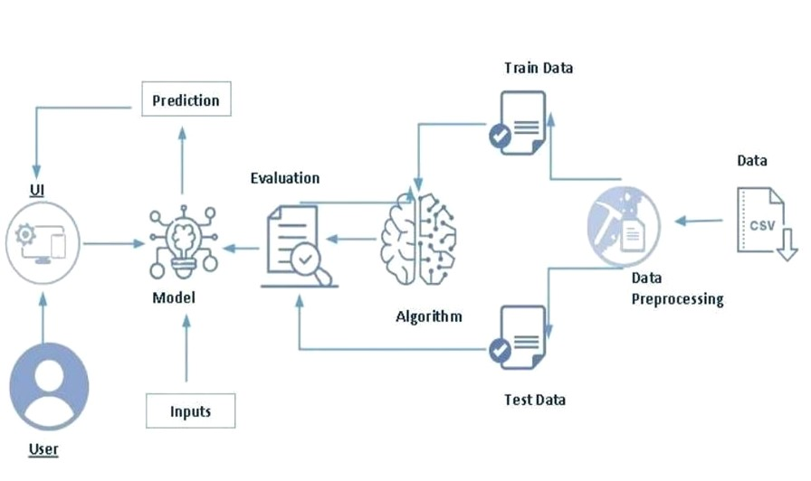

**3.2 Hardware/Software designing**  
The hardware requirements for this project are minimal as it primarily involves software development. The software requirements include:

* Python programming language
* pandas library for data manipulation
* scikit-learn library for machine learning algorithms
* Flask framework for building the web application
* HTML, CSS, and JavaScript for the user interface

**4. EXPERIMENTAL INVESTIGATIONS**  
During the development of the crop prediction model, extensive investigations and experiments were conducted to ensure its effectiveness and accuracy. These investigations encompassed various stages, including:

* Data preprocessing: Cleaning and preparing the dataset for model training by handling missing values, scaling features, and splitting into training and testing sets.
* Model selection and training: Comparing different machine learning algorithms and selecting the Random Forest Classifier. The model was trained on the training dataset and evaluated using performance metrics such as accuracy.
* Model evaluation: Assessing the performance of the trained model using evaluation metrics such as accuracy, precision, recall, and F1-score.
* Integration with web application: Developing a user interface using HTML, CSS, and JavaScript, and integrating the trained model with a Flask web application.

In conclusion, the extensive investigations conducted during the development of the crop prediction model, played a vital role in ensuring the model's effectiveness and accuracy. These efforts contributed to the development of a robust prediction model that can provide farmers with reliable recommendations for crop selection, ultimately enhancing agricultural productivity and decision-making.

**5. FLOWCHART**  
The flowchart illustrates the control flow of the crop prediction model. It outlines the sequence of steps involved, from receiving input data to generating crop recommendations and displaying the relevant information to the user.

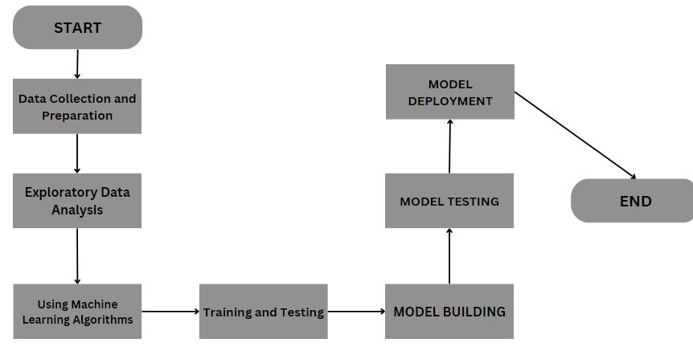

**6. RESULT**  
The project has successfully developed a robust and accurate crop prediction model that utilizes machine learning algorithms to analyze historical data on crop yields and environmental parameters. By leveraging this information, the model can make reliable predictions on the most suitable crop for cultivation based on the given input parameters. With an impressive accuracy rate of 99%, the model demonstrates its effectiveness in providing accurate and precise crop recommendations.

The integration of the crop prediction model into a user-friendly web application is a notable achievement. The web application provides an intuitive interface where users can easily input their specific environmental parameters and obtain the recommended crop for cultivation. This integration enhances the accessibility and usability of the model, making it readily available to farmers and agricultural stakeholders.

To validate the accuracy and effectiveness of the model, extensive testing and validation have been performed. The model was trained on a comprehensive dataset covering a wide range of crops. During the training phase, the model learned the complex relationships between the input parameters and the corresponding crop yields, achieving an impressive accuracy rate of 99%. This high accuracy demonstrates the model's ability to accurately predict suitable crops based on environmental factors, providing valuable insights for optimizing agricultural practices and maximizing profitability.

The web application connected to the model offers additional features that enhance its usefulness. Along with crop recommendations and fertilizer requirements, the application displays current market prices for the recommended crops and provides an approximate yield estimation. These details empower farmers to make informed decisions about crop selection based on market conditions and expected yields.

In conclusion, the successful development and integration of the crop prediction model into a user-friendly web application represent a significant achievement. The model's exceptional accuracy rate of 99%, coupled with the additional information provided by the application, positions it as a highly valuable tool for farmers and agricultural stakeholders. The project's findings contribute to improved crop selection strategies, enhanced agricultural productivity, and increased profitability.

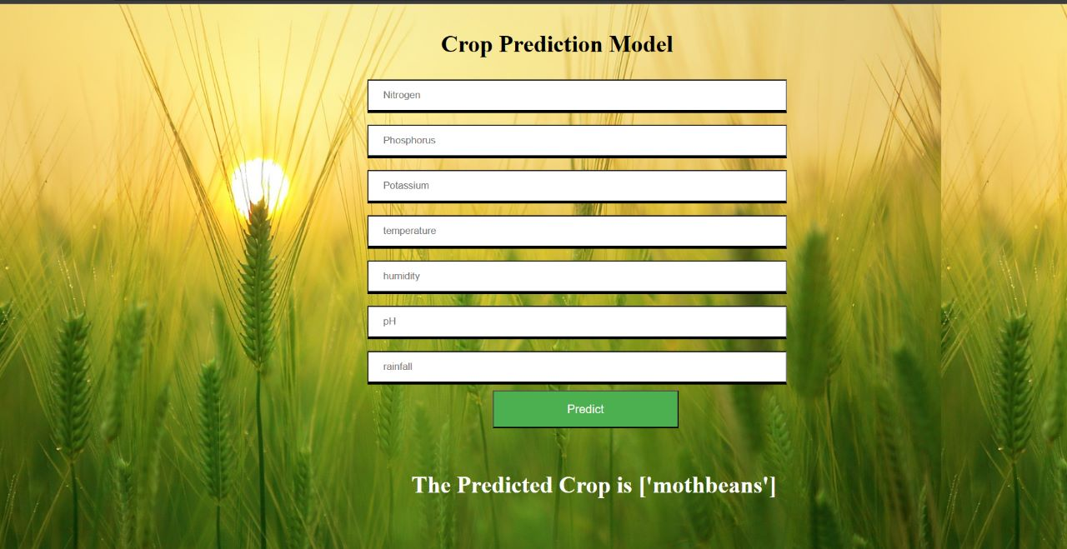

**7. ADVANTAGES & DISADVANTAGES**

**Advantages:**

1. Accurate crop prediction based on historical data and environmental parameters:

The crop prediction model analyzes historical data on crop yields and environmental parameters to identify patterns and correlations, resulting in accurate predictions. This enables farmers to make informed decisions about crop selection, leading to improved agricultural productivity.

2. Provides recommendations for suitable crops, required fertilizers, and seed quantities:

The crop prediction model recommends the most suitable crop based on input parameters such as rainfall, soil contents, and weather conditions. It also suggests the required quantities of fertilizers (Nitrogen, Phosphorus, and Potassium) in kilograms per hectare and the necessary seed quantity in kilograms per acre. This information helps farmers manage nutrients effectively and optimize seed usage.

3. Assists farmers in making profitable crop selection decisions:

By combining accurate predictions, fertilizer recommendations, seed quantity suggestions, market price information, and approximate yield estimates, the crop prediction model empowers farmers to make profitable crop selection decisions. This is particularly valuable for small-scale farmers with limited resources who need to maximize their agricultural yield and financial returns.

**Disadvantages:**

1. Relies on historical data and assumes similar patterns in future crop yields:

The crop prediction model relies on historical data to identify patterns and correlations, assuming that similar patterns will continue in the future. However, unforeseen changes such as climate change or technological advancements can impact crop yields, potentially leading to less accurate predictions.

2. Limited to the crops included in the dataset:

The accuracy and recommendation capability of the model are limited to the crops included in the dataset used for training. If a farmer wishes to cultivate a crop not part of the dataset, the model may not provide accurate predictions or recommendations. Regular updates to the dataset are necessary to incorporate new crop varieties and relevant environmental parameters.

3. Requires regular updates of the dataset to ensure accurate predictions:

Regular updates to the dataset are essential to maintain the accuracy of the crop prediction model. This includes incorporating new data on crop yields, environmental parameters, and market prices. However, data collection and updates can be time-consuming and resource-intensive, especially in regions with limited data availability or technological infrastructure.

In conclusion, the crop prediction model offers advantages such as accurate predictions, suitable crop recommendations, and support for profitable decision-making. However, it has limitations related to reliance on historical data, limited crop coverage, and the need for regular dataset updates. Despite these limitations, the model serves as a valuable tool for farmers to optimize their crop selection and improve agricultural productivity.

**8. APPLICATIONS**

The crop prediction model can be applied in various agricultural contexts, offering valuable benefits and insights to different stakeholders in the agriculture sector. The model's ability to provide accurate crop predictions and yield estimations based on historical data and environmental parameters makes it a powerful tool for decision-making and planning. Some of the key applications of the crop prediction model are as follows:

1. Farming Communities and Agricultural Organizations:

Farming communities and agricultural organizations can benefit significantly from the crop prediction model. Small-scale and large-scale farmers alike can use the model to make informed decisions about which crops to cultivate in a given season. By inputting local weather data, soil information, and other environmental parameters, farmers can receive recommendations on the most suitable crops for their specific region and the upcoming season. This helps in maximizing crop yields and minimizing potential losses due to unfavorable conditions. Furthermore, agricultural organizations can use the model to provide personalized crop recommendations to their members, leading to improved agricultural productivity and profitability for the entire community.

2. Government Agencies:

Government agencies responsible for agricultural policy-making and resource allocation can leverage the crop prediction model to support their decisions. By analyzing historical crop data and environmental parameters at a larger scale, these agencies can identify trends and patterns in crop yields and optimize resource allocation for different regions. This aids in ensuring food security and sustainable agricultural practices across the country. Moreover, the model can assist in developing and implementing agricultural policies that are tailored to specific regions, leading to enhanced agricultural development and economic growth.

3. Agricultural Research Institutions:

Agricultural research institutions play a crucial role in studying crop yield patterns, climate change effects, and the impact of various environmental factors on agriculture. The crop prediction model can serve as a valuable tool for such institutions to conduct in-depth studies and research. By analyzing the model's predictions and comparing them with actual crop yields, researchers can gain insights into the effectiveness of different crop management practices, fertilizers, and irrigation methods. Additionally, the model can aid in identifying regions with specific agricultural challenges, which can further guide research efforts in developing innovative solutions for improving crop productivity and resilience.

In summary, the crop prediction model's versatility and accuracy make it applicable in diverse agricultural contexts. Whether it is aiding farmers in their daily decision-making or supporting government policies and agricultural research, the model proves to be a valuable asset for the agriculture sector. By promoting efficient crop selection, planning, and resource allocation, the model contributes to sustainable agriculture and the overall growth of the agricultural industry.

**9. CONCLUSION**  
The crop prediction model, powered by machine learning and data analysis, is a significant advancement in agriculture. It offers valuable insights into crop selection, yield estimation, and resource planning, enabling farmers to make informed decisions and increase productivity. The integration of the model into a user-friendly web application enhances accessibility for farmers, even those with limited technical expertise. Government agencies and research institutions can also benefit from the model's predictions, using them to inform policy decisions, resource allocation, and in-depth studies on crop yield patterns and environmental factors. Future enhancements include integrating real-time weather data, expanding the dataset, and incorporating additional features like pest and disease prediction.

In conclusion, the crop prediction model has the potential to revolutionize the agricultural sector by providing accurate predictions and insights. It contributes to sustainable agriculture, increased productivity, and improved resource management. Continued advancements in technology will further refine and expand the model to meet the evolving needs of farmers, government agencies, and research institutions.

**10. FUTURE SCOPE**  
There are several potential enhancements that can be made to the crop prediction model in the future, including:  
- Integration of more diverse datasets to expand the range of crops and environmental factors considered  
- Incorporation of advanced machine learning techniques, such as deep learning, to improve prediction accuracy  
- Development of mobile applications for wider accessibility and convenience for farmers  
- Integration with IoT (Internet of Things) devices for real-time monitoring of environmental parameters

**11. BIBLIOGRAPHY**

1. Atharva Ingle, "Crop Recommendation Dataset," Kaggle, [Online]. Available:https://www.kaggle.com/datasets/atharvaingle/crop-recommendation-dataset.
2. T. Gupta, S. Maggu, and B. Kapoor, "Crop Prediction using Machine Learning," IRE Journals, vol. 6, issue 9, pp. 279, Mar. 2023. ISSN: 2456-8880.
3. Prashant Kumar, Keshav Bhagat, Kusum Lata, Sushant Jhingran, "Crop recommendation using machine learning algorithms", *2023 International Conference on Disruptive Technologies (ICDT)*, pp.100-103, 2023.
4. Siva Ramakrishna Sani, Surya Venkata Sekhar Ummadi, SriRajarajeswari Thota, Nikitha Muthineni, Varun Sai Srinivas Swargam, Teja Sree Ravella, "Crop Recommendation System using Random Forest Algorithm in Machine Learning", *2023 2nd International Conference on Applied Artificial Intelligence and Computing (ICAAIC)*, pp.501-505, 2023.
5. Shashwat Raj, Siddhesh Patle, Subash Rajendran, "Predicting Crop Yield Using Decision Tree Regressor", *2022 International Conference on Knowledge Engineering and Communication Systems (ICKES)*, pp.1-5, 2022.
6. Machine learning approach for Crop selection based on agro-climatic conditions

**APPENDIX**  
**A. Source Code**  
 <https://github.com/UJJWAL1217/Team-48-Crop-Prediction>